Pharmacy stamp

Test used : ………………………………………………….
Batch number : …………………………………………….
Expiration date : ……………………………………………

Result report
Test date : …………………………………………………………………..……….
Patient’s name : …………………………………………………………………….
Date of birth : ………………………………………………………………………..
Health number : ……………………………………………………………………..
Postal code : …………………………………………………………………………
Phone number : ……………………………………………………………………..

Mr/Mrs
Today, you underwent an antigenic test for covid-19.
Depending on the result, please refer to the indications below.

- THE RESULT IS NEGATIVE : You have probably not been exposed to SARS-CoV-2.

- THE RESULT IS POSITIVE

You must complete a self-isolated period to break the chain of infection
  - You have symptoms: you must complete a 7-days isolation period. Your isolation period includes the day your symptoms started after the appearance of the first symptoms.
  - You have no symptom: you must complete a 7-days isolation period. Your isolation period includes the day your test was taken.

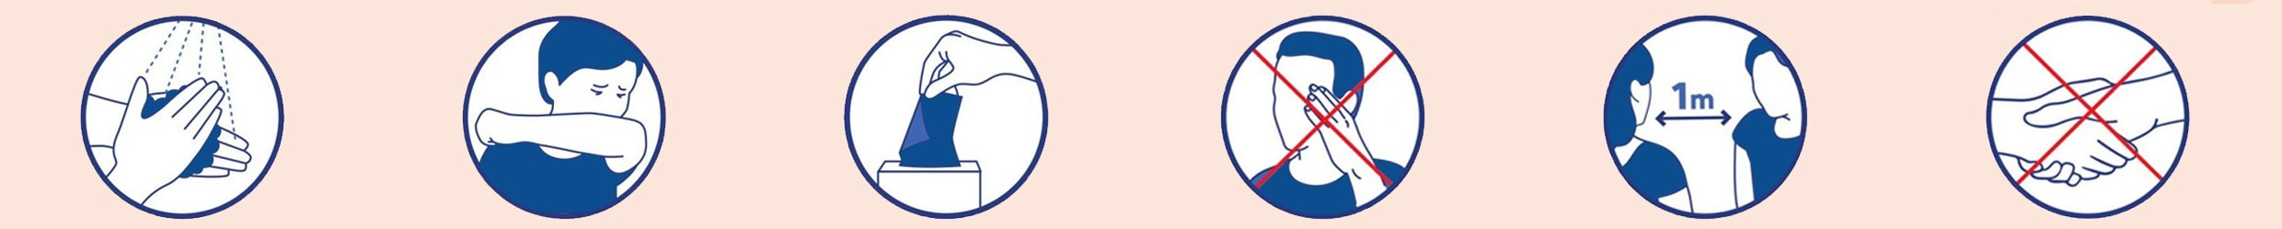
Whatever the result of my antigenic test, I must observe the key behaviours

